AHEIA
Teachers’ Workshop
July 29-31, 2024

Hosted at the Alford Lake
Conservation Education Centre For Excellence

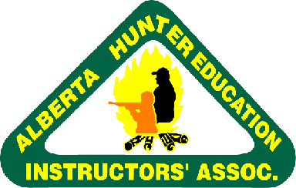
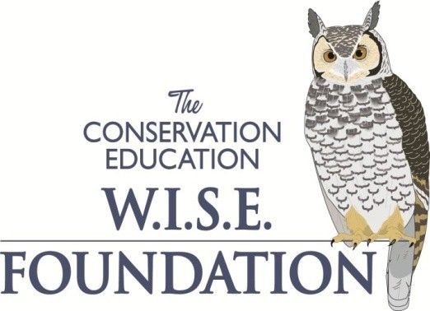

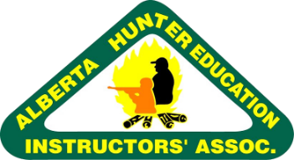
AHEIA’s
Teacher’s Workshop
NASP Basic Archery Instructor Course July 29, 2024
Hunter Ed/Fishing Ed/PCOT Workshop: July 30/31, 2024

The AHEIA Teachers’ Workshop is held annually at the AHEIA Alford Lake Conservation Education Center for Excellence. Attendees can certify to teach Hunter Education, Fishing Education, Pleasure Craft Operator Training, and the AHEIA NASP Program. These programs are offered in Alberta Schools through the Alberta Education curriculum within the Careers and Technology Studies option, Natural Resources (NAT) Program and Careers and Technology Foundations Programs for Grades 5 to 9. The programs offered at the AHEIA Teachers’ Workshop meet all requirements specified by the Alberta Education curriculum guide.

Hunter Education/Fishing Education

In 1964, the Alberta Government, together with Alberta outdoorsmen, created a hunter safety program which later became the Alberta Conservation and Hunter Education program. Each year, approximately 15,000 students complete the Conservation Education program, and 6,500 students complete the Fishing Education program.
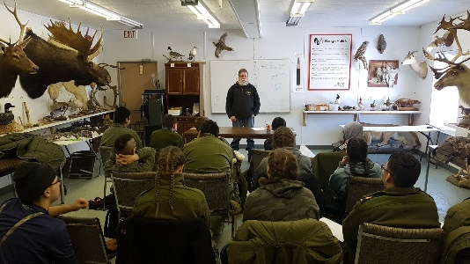
As of April 1, 2010, all first-time hunters in the Province of Alberta are required to complete the Alberta Conservation and Hunter Education program or an equivalent hunter education course in order to purchase a hunting licence.

AHEIA has developed a specific workshop for teachers related to the NAT cluster.

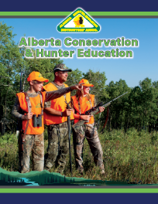

The main component of the workshop will offer participants the required certification for delivering the “Natural Resource (NAT) Course – Wildlife” program. This certification from the Alberta Hunter Education Instructors’ Association will be offered in:

- Alberta Conservation & Hunter Education Program (WLD1070, WLD2070)
- Alberta Fishing Education Program (WLD1080, WLD2080)

AHEIA’s
Teacher’s Workshop
NASP Basic Archery Instructor Course July 29, 2024
Hunter Ed/Fishing Ed/PCOT Workshop: July 30/31, 2024

An additional component of the workshop will familiarize teachers with activities at our Outdoor Camps as they relate to Outdoor Experience I and II (WLD1130, WLD2130). These sessions include hands-on participation in:
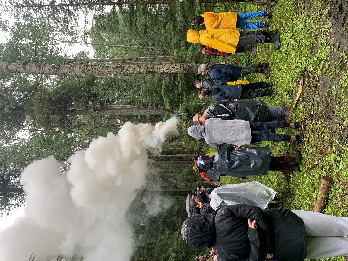
- Survival & Camping Program
- Shooting Program (shotgun, small bore rifle & large bore rifle)
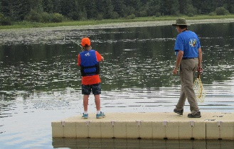
- Compass Program
- Fishing Program
- Archery Program

AHEIA National Archery in the Schools Program (NASP®) Basic Archery Instructor

The program's focus is to provide International Style Target Archery training in physical education classes grades 4-12. It is designed to allow students of all backgrounds and abilities to flourish.
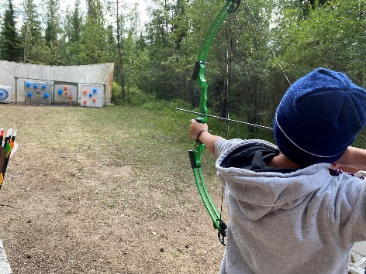
The Basic Archery Instructor (BAI) certification provides instructors with the knowledge of how to safely set up the range, teach the program, maintain equipment, and ensure the safety of students, bystanders, and the facility.
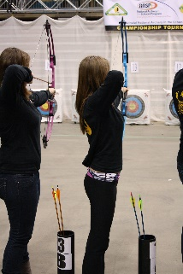
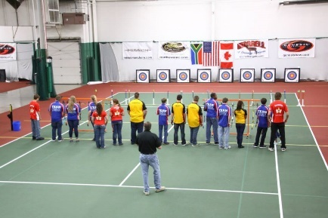
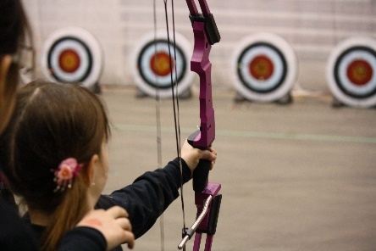
To register for the NASP portion of the camp, the participant must either already be a Hunter Education Instructor or be completing the Hunter Education Instructor program offered during this week. The NASP certification will be delivered via hybrid instruction which requires the participant to do a 4-hour online course prior to attending the camp. At the camp, the in-person session will include a review of the online program and the hands-on training on the range. Once teachers have successfully completed this program, equipment can then be ordered through NASP®. AHEIA offers yearly grants towards the purchase of equipment that teachers can apply for online at https://aheia.com/nasp.

AHEIA’s
Teacher’s Workshop
NASP Basic Archery Instructor Course July 29, 2024
Hunter Ed/Fishing Ed/PCOT Workshop: July 30/31, 2024

Pleasure Craft Operator Training (PCOT) Instructor Course
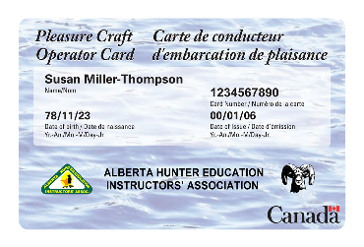
Did you know that anyone driving a motorized pleasure craft anywhere in Canada requires a Pleasure Craft Operator Card? These cards can only be obtained by passing a Transport Canada Boating Safety Course. There is no minimum age requirement to take this course.
The PCOT course is designed for new boaters to come to understand boating restrictions, personal and vessel safety, equipment, following the rules on the water, preventing, and responding to emergencies.
As a PCOT instructor you will be able to provide your students with a course that will give the Canada-wide certification to operate a motorized pleasure craft.
Alford Lake Camp

The workshops will be held at the Alford Lake Conservation Education Centre located 24 km West of Caroline (See attached map).

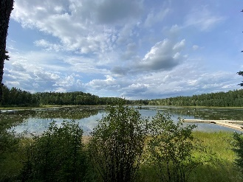
Established in 1974, the Alford Lake Conservation Education Centre for Excellence is designed to provide Wildlife Conservation Education students with an opportunity to experience hands on involvement in programs that introduce them to the outdoors and outdoor skills. The emphasis is always on safety. This location is an excellent facility to utilize as a field study opportunity for your students.

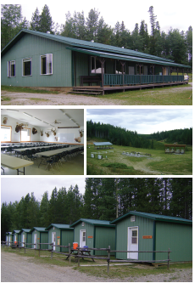
Alford Lake camp is available for private bookings to our members. The facility features:

- Archery ranges
- Fishing education area
- RV parking area for up to 16 units
- Wilderness survival training area
- Firearm safety training ranges
- Wildlife and Fisheries identification
- Outdoor cooking area
- Equipment storage and maintenance facilities
- Camp administration building
- Map and compass course
- Large meeting room/dining room complete with food service capability.
- Washrooms and showers
- Cabins that are winterized and will accommodate over 100 people.
- Classroom

AHEIA’s
Teacher’s Workshop
NASP Basic Archery Instructor Course July 29, 2024
Hunter Ed/Fishing Ed/PCOT Workshop: July 30/31, 2024

Registration

Registration is limited. If you are interested in this workshop, please register online at https://aheia.com/events#section_10818 no later than June 28, 2024. If you have any questions, comments, or concerns please contact us as soon as possible at the email addresses or phone numbers below.

The teacher’s workshop registration fee is $300.00 per person plus GST ($315.00) and includes the Hunter Education/Fishing Education and PCOT instructors’ courses. The AHEIA NASP Basic Archery Instructor Program instructor course is an additional $100.00 plus GST ($105.00). We supply all meals, accommodations (cabins), all resource materials, instructor certifications and a seventeen-month membership into our organization.

All participants registering and staying in the cabins will need to bring a sleeping bag, pillow, alarm clock, towel, soap, and other personal items. Many activities are scheduled outdoors, so appropriate dress is recommended. Teachers may bring their own personal gear for all hands-on activities.
Please note that cancellation prior to June 28, 2024, entitles you to a full refund less a $50.00 administration charge. No refunds are provided after June 28, 2024.
Looking forward to seeing you there!

Aislinn Chapotelle
Calgary Conservation Education Centre aislinn@aheia.com
403.319.2286 or 866.852.4342

AHEIA’s
Teacher’s Workshop
NASP Basic Archery Instructor Course July 29, 2024
Hunter Ed/Fishing Ed/PCOT Workshop: July 30/31, 2024

Location

Alford Lake Conservation Education Centre for Excellence is located approximately one- hour drive West of Innisfail on Highways 54 and 591 (about 24 km West of Caroline) and then approximately 1.6 km North of Highway 591 on Range Road 8-3 North.

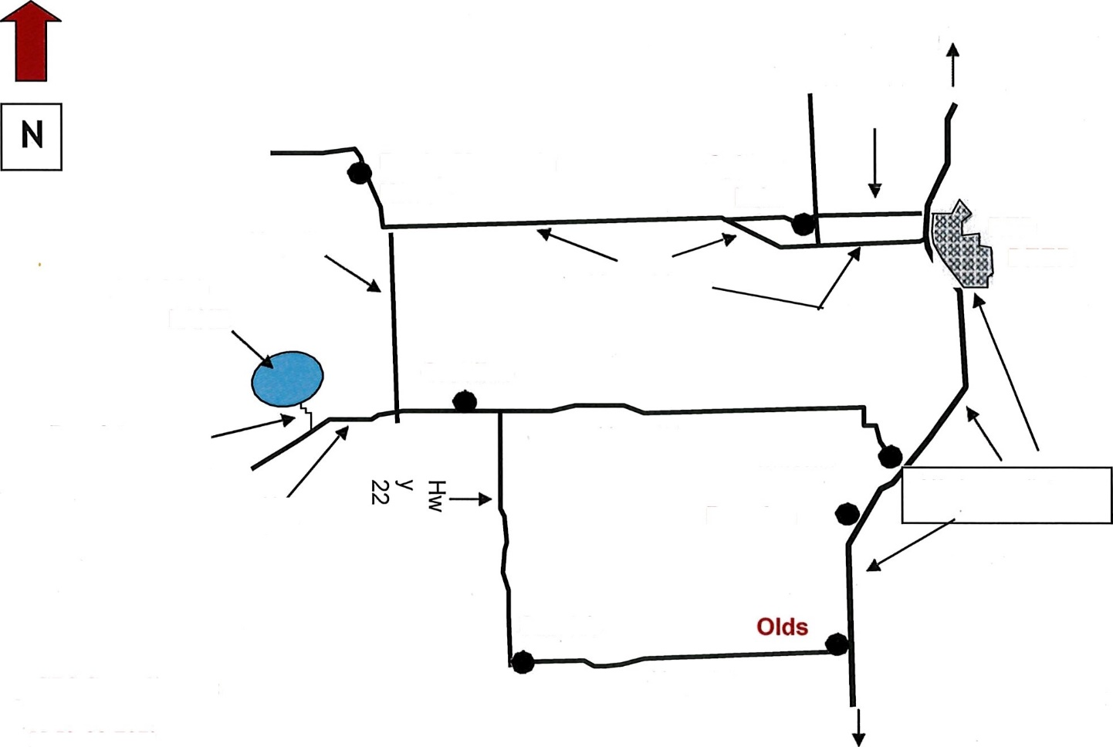
Watch for our camp sign at the North side of Highway 591, marking the turn off towards Alford Lake on
Hwy. 11A
Rocky Mountain
House
Sylvan
Lake
Hwy 22
RED
DEER
ALFORD
LAKE
Hwy. 11
Caroline
Hwy. 54
Innisfail
Hwy 591
Highway #2
Bowden
Sundre
Hwy. 27
Camp GPS Co-ordinates:

N 52-03.707’
W 115-05.453’

Range Road 8-3
Range Road 8-3 North.

Calgary

Alford Lake Conservation Education Centre for Excellence Box 369 Caroline, Alberta TOM 0M0
Phone: (403) 722-2423 Fax: (403) 722-2445
Email: alfordlake@xplornet.com

